- We think that valid concerns about the quality of data from the UK's Labour Force Survey (LFS) make it virtually unusable at present. Considering it will likely take another two years to fix the problems, this poses a major headache for policymakers and economists alike.
- Response rates to the LFS remain very low, resulting in significant data volatility. The challenges have been compounded by the Office for National Statistics also having problems measuring the size and structure of the population.
- As a result, LFS estimates of employment are probably too low, while it's looking increasingly likely that the UK's inactivity problem is less serious than previously feared.
- Our proprietary sentiment data, developed with Penta, fills part of the information void, acting as a check on official data as well as being timelier. Our nowcasts using this sentiment data suggest employment growth is slowing to zero, and private sector regular pay growth stabilising at around 4.5% at the turn of the year.
- These results highlight the trade-off recently identified by the Bank of England's Monetary Policy Committee between persisting inflation and weak growth and employment prospects.
Chart 1: Our sentiment-based nowcast suggests employment growth stalled in H2 2024
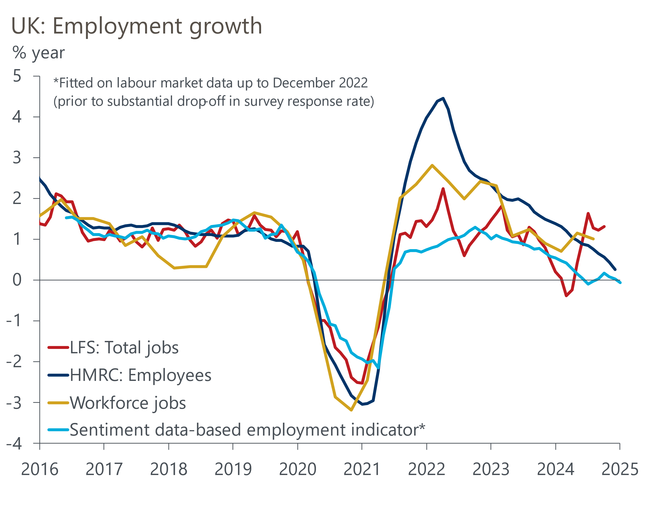
Source: Oxford Economics/Penta/Haver Analytics
The labour market is a key source of uncertainty for the UK economy in 2025. To understand the issues and potential outcomes, we're publishing a series of notes, beginning with our recent report on the key uncertainties. Here, we examine the challenges posed by data problems and how they can be mitigated.
There's been a major loss of faith in the information from the Office for National Statistics' key Labour Force Survey. LFS series are now designated as 'official statistics in development', indicating they're of a lower standard than most core macroeconomic datasets, such as GDP or inflation. The ONS has been candid about the seriousness of the problems, but progress in addressing them has been glacial. Now, it seems the problems won't be fully resolved for another two years.

LFS problems are largely due to low response rates
The problems with LFS data have been building for more than a decade. Survey response rates were close to 50% in 2013 but had drifted below 40% by 2019. The onset of the pandemic and the switch from face-to-face interviews to carrying out the survey by phone, which was forced by social-distancing restrictions, caused response rates to plunge, reaching a low of just 12.7% in Q3 2023. This meant that just 35,000 survey responses were used to represent 55mn people aged 16 and over. The average masks even lower response rates among some groups, exacerbating concerns about how representative the results are.
The UK is far from the only country experiencing this problem – our US team recently wrote about the implications of falling response rates for a range of surveys used to calculate US economic data. But the problems in the UK are perhaps the most acute. In fact, the collapse in response rates in mid-2023 led to the ONS suspending publication of LFS data for five months, although this resumed in early-2024.
Still, the most serious problems remain unresolved. Most notably, efforts to increase sample sizes and improve response rates have yielded only modest success. In Q3 2024, the response rate was just 19.5% – around half the pre-pandemic level. This resulted in 47,000 survey responses, compared with an average of just over 70,000 in 2019.

LFS series have become more volatile and revision-prone
Plummeting response rates have damaged the quality of LFS data. The ONS uses the three-month average of monthly observations as its headline series for the unemployment rate. Recently the range of monthly estimates used to calculate the three-month average has been much wider than before the pandemic – on one occasion in 2023, the difference between the highest and lowest estimates was 1ppt for a three-month average of 4.2% (Chart 2). Noisy data makes it harder to identify genuine trends and turning points.
Chart 2: Unemployment estimates have become very noisy since the start of the pandemic
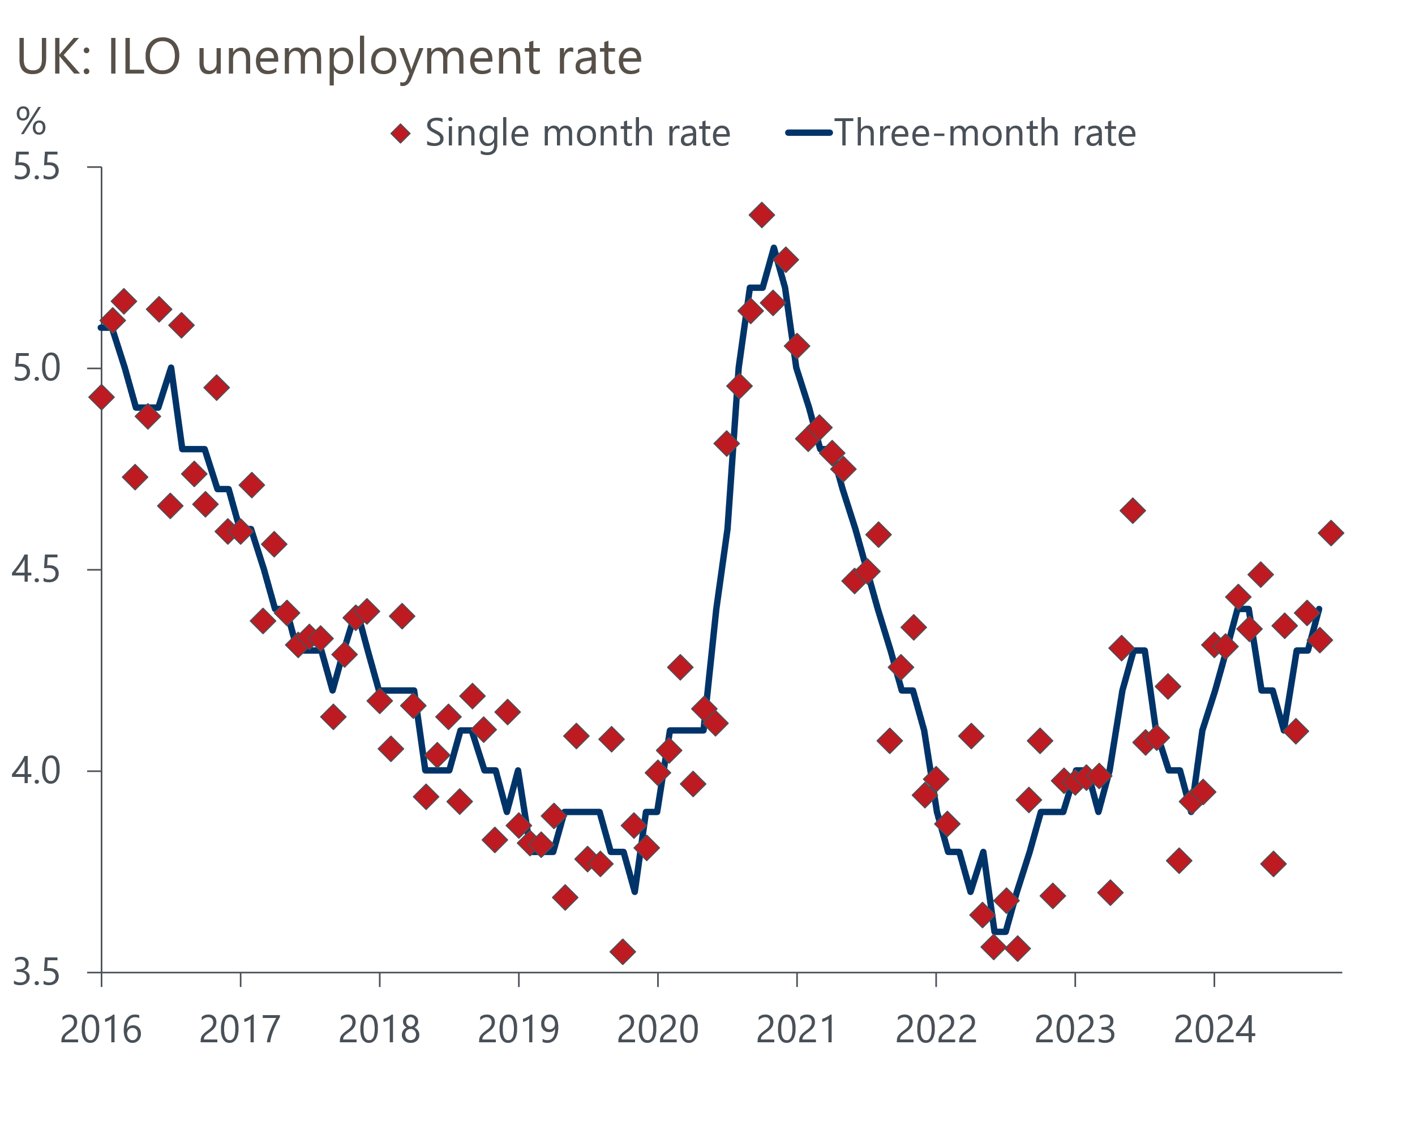
Source: Haver Analytics
The LFS has also told a markedly different story about employment since the start of the pandemic. The current vintage of the LFS suggests the number of employees remained higher than 2019 levels throughout the pandemic, in contrast to the ONS' workforce jobs measure and HMRC's count of employees on payrolls, which both reported falls in employees of more than 500,000. Furthermore, while the HMRC and workforce jobs measures have shown similarly strong recoveries since early 2021, the trajectory of the LFS series has been much flatter, and up until a very strong data point for Q3 2024 it had been well below the other series (Chart 3).
Chart 3: The trend in employee numbers reported by the LFS has been very different to other sources
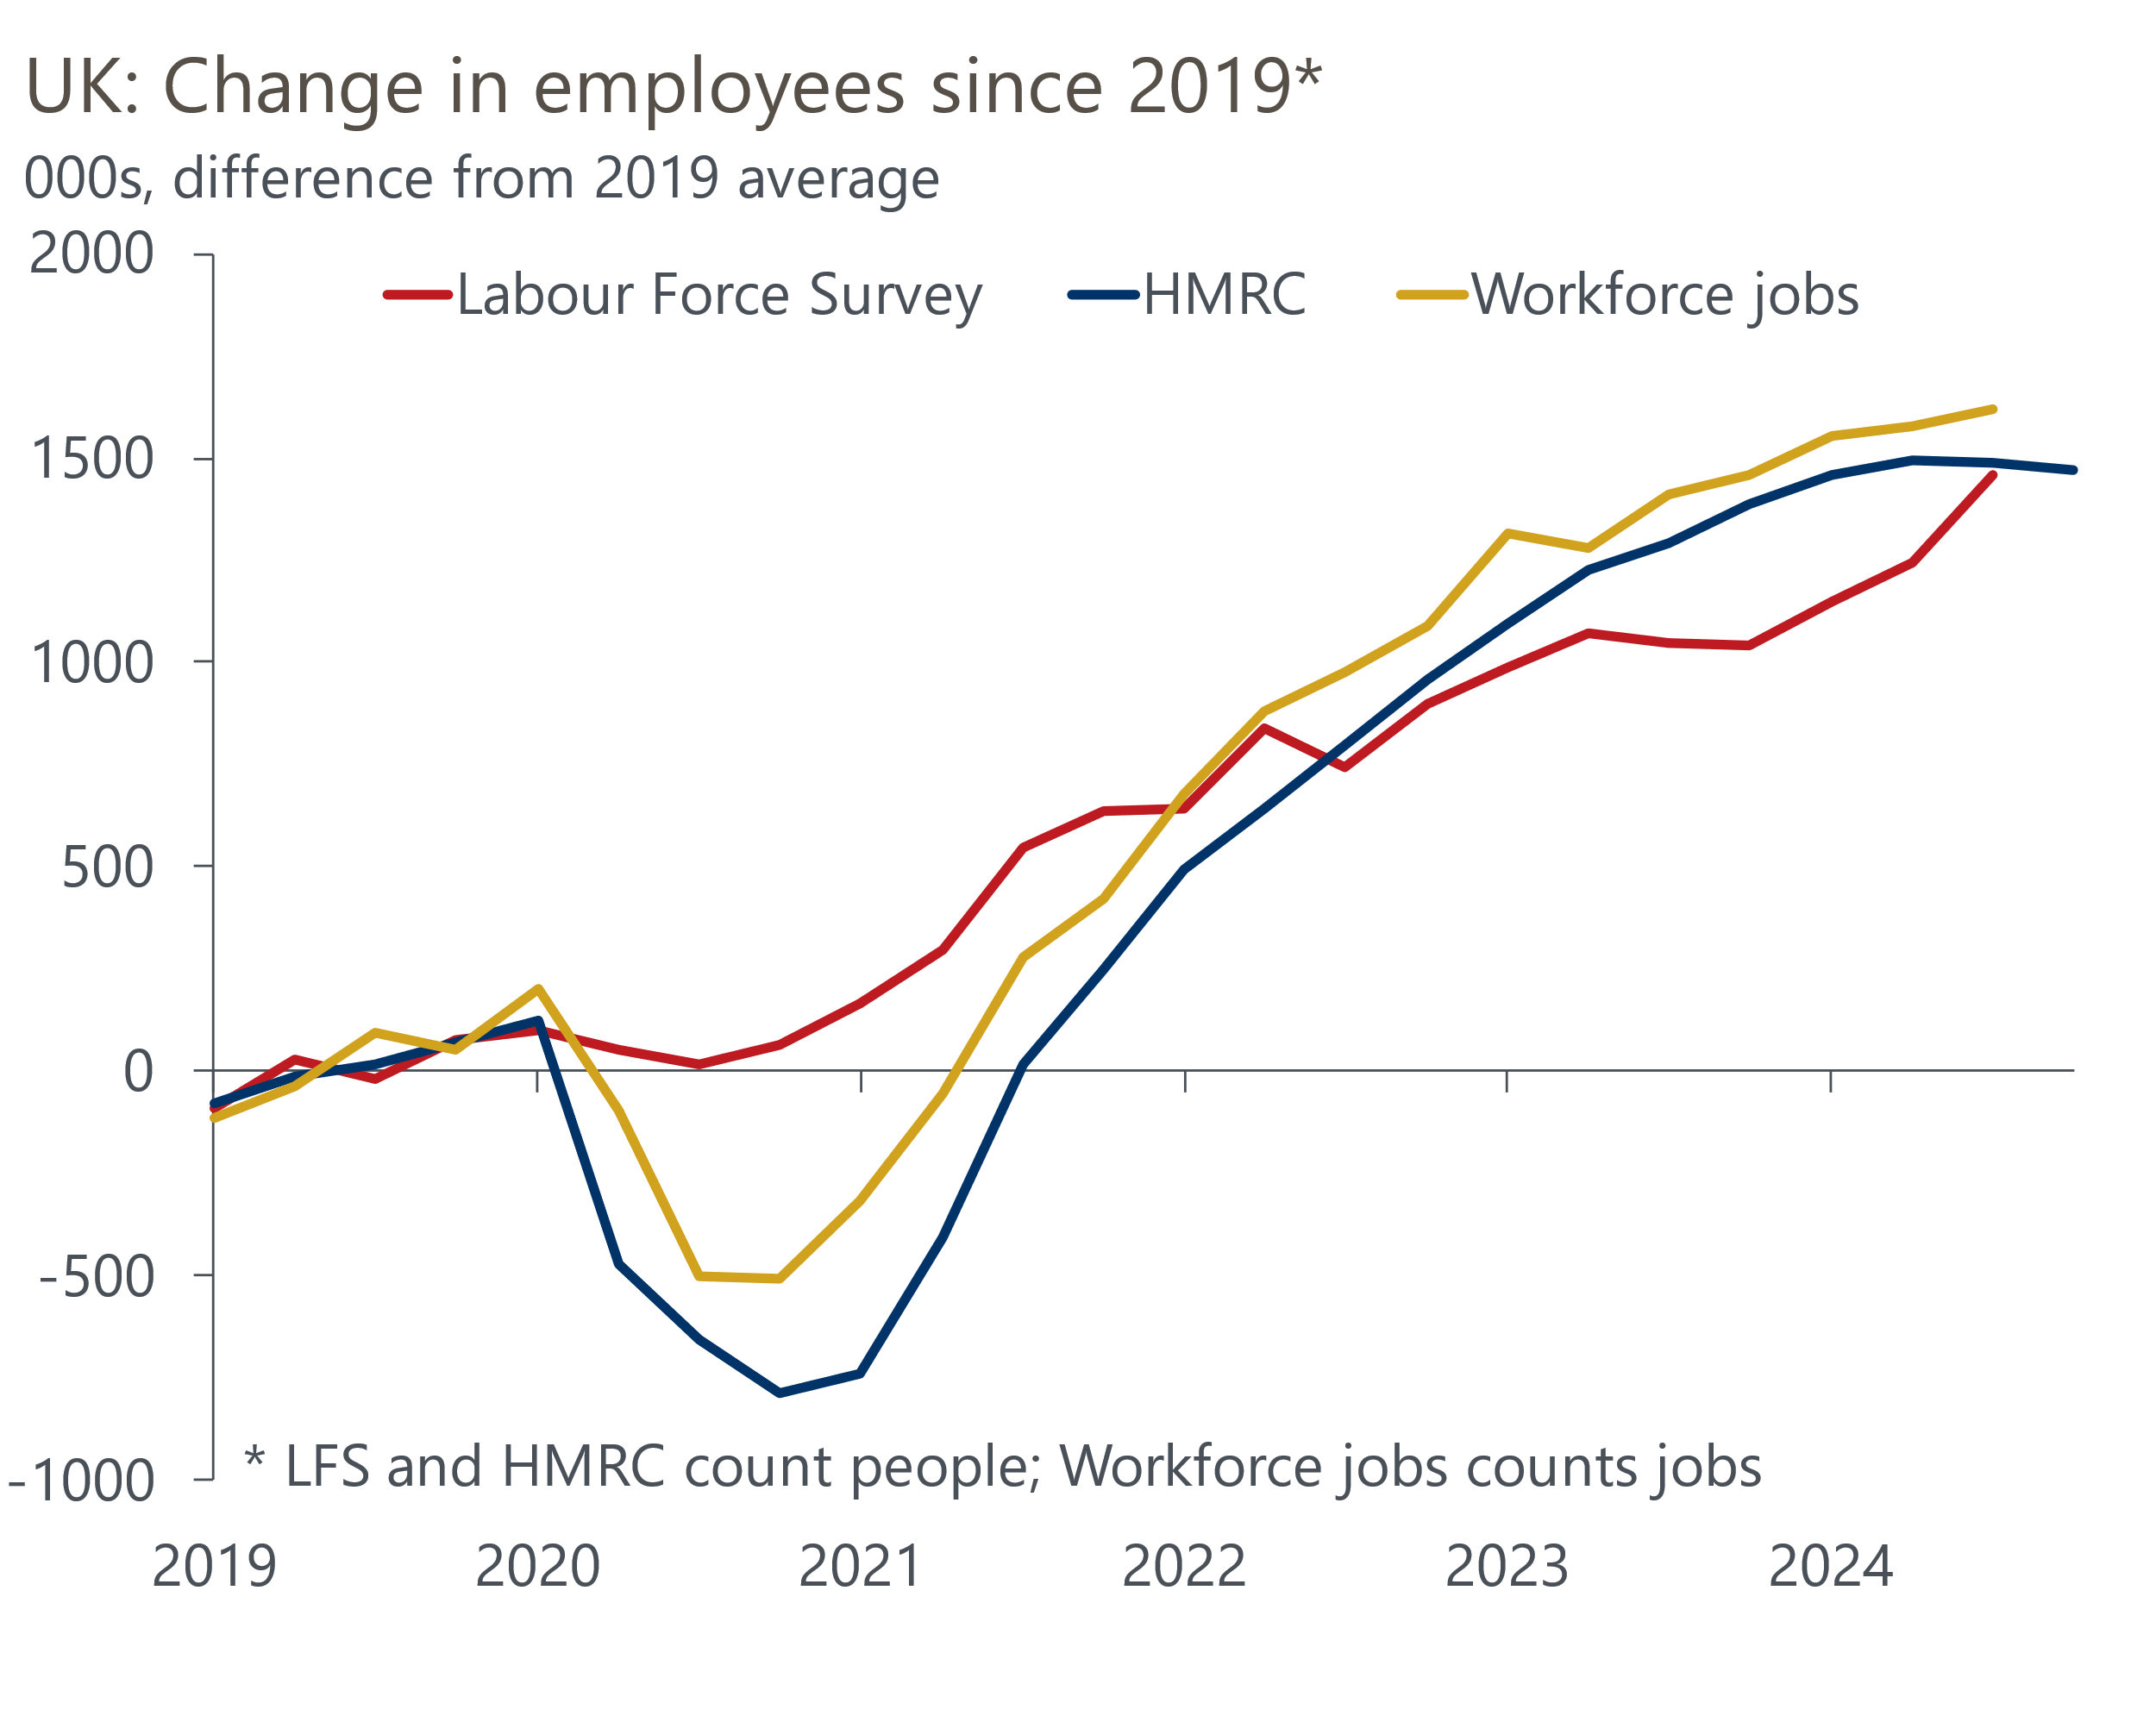
Source: Oxford Economics calculations using data from Haver Analytics

Problems measuring population are also part of the story
In addition to the problems with response rates, the quality of the LFS data is also being undermined by difficulties in measuring the population. Given the LFS is a survey with a relatively small sample, it relies on accurate data for the size and structure of the population to gross up the survey results to produce figures for the whole economy.
As with the LFS, problems with population measures were exacerbated by the pandemic, when the ONS suspended its main source of migration data, the International Passenger Survey. Given that immigration has been running at record levels in recent years, in part due to the special visa schemes for migrants from Ukraine and Hong Kong, there could scarcely be a worse time for the ONS to lose its main data source and be forced to overhaul its methodology.
Progress towards a permanent replacement for the IPS has been slow. The ONS has introduced a series of methodological improvements that have led to regular revisions to population estimates and, therefore, the LFS series. When the LFS was suspended in October 2023, the most recent data point was for Q2 2023 and showed total employment of 32.9mn. The latest estimate for that quarter is 427,000 (1.3%) higher at 33.4mn (Chart 4).
Chart 4: Higher population estimates have caused LFS employment to be revised up significantly
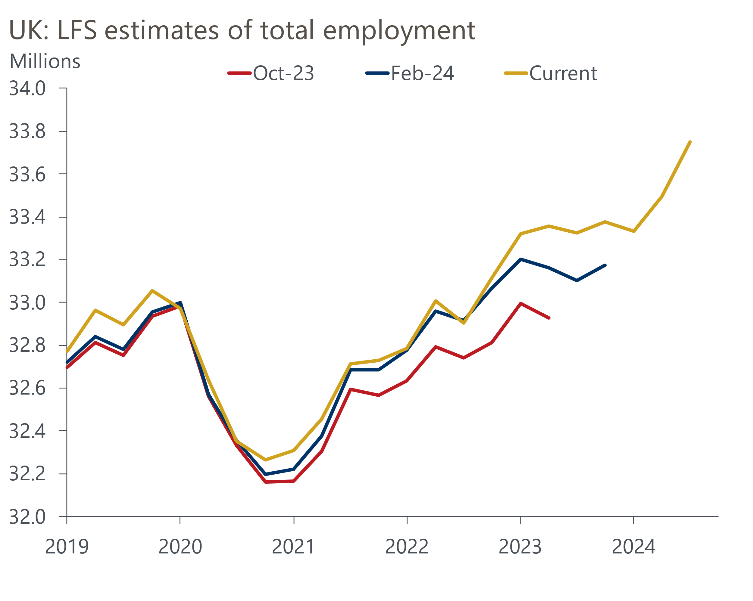
Source: ONS
Moreover, the latest data is probably still an under-estimate of the true level of employment. In November, the ONS made large upgrades to its estimates of net inward migration, with net inflows from mid-2021 to mid-2024 now reported to have been 435,000 higher than was assumed in the most recent population projections (Chart 5).
Chart 5: The latest, much higher, immigration data is yet to be incorporated into the LFS
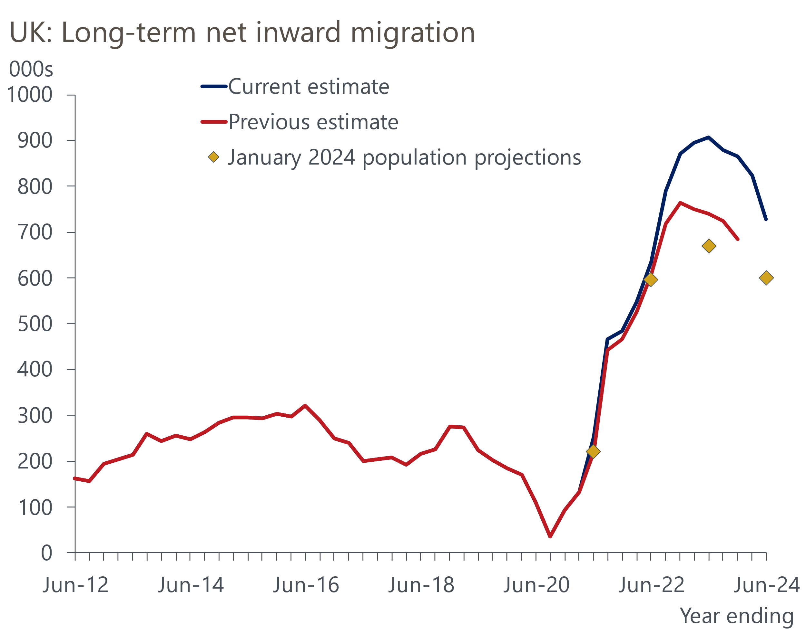
Source: ONS
The ONS is yet to integrate the new figures into its population estimates or its LFS series. So it's likely that the LFS estimates of total employment will be upgraded again in the near future. And given the ONS has still not finished overhauling its methodology for measuring population, we could still see another set of material revisions to the LFS series later.

Policymakers are flying blind without reliable data
Such noisy and revision-prone data has caused major problems for policymakers. The Monetary Policy Committee's response to the inflation shock was heavily influenced by its judgment on the likely strength of second-round effects via pay growth. But the absence of accurate data on employment, unemployment, or inactivity, made it very difficult for the MPC to judge how tight the labour market was and may have contributed to policymakers underestimating the strength of second-round effects.
Government policy has also been affected by data problems. Successive governments have sought to introduce policies to tackle an apparent surge in inactivity, a legacy of the pandemic that appeared unique to the UK among the major economies. But it's possible that the rise in inactivity is a statistical mirage rather than a genuine problem. Recent research from Resolution Foundation argued that the LFS problems resulted in the inactivity rate being "materially overestimated" and Bank of England Chief Economist Huw Pill recently suggested that its research was leaning towards a similar conclusion.

Long wait for a permanent fix means we need to rely more on other sources
In our view, in its current form the LFS data is close to unusable. Indeed, the ONS probably made a mistake in reinstating the data in early 2024 without having fixed the main problems, because it created a false impression of reliability.
When the LFS was suspended in 2023, the ONS expected the new Transformed LFS – its long-term successor – would be "the primary source for the labour market release in March 2024." But that timetable has progressively slipped. Now the ONS says that transitioning to TLFS in mid-2025 is "unlikely" and its aim is to complete the process in 2027, although there will be further piecemeal improvements to the LFS in the interim.
It's hard to see why it will take so long to resolve the problems. If the proposed timetable holds, the UK will endure a four-year period without reliable data for its key labour market series. The LFS is the cornerstone of the UK's labour market data – of the 10 series that we charted in our recent labour market note, seven used the LFS as an input. Moreover, while the ONS reinstated the headline LFS series in early 2024, much of the finer detail is still unavailable. So it's possible that in important areas such as labour market flows, there will be long gaps in time series.
The long wait for a permanent fix means it's vital to use other sources to gauge the strength of the labour market. Series like HMRC's count of payrolled employees are important in this regard, though they too have flaws – as our previous analysis found, the HMRC series appears to have a downward bias to its revisions, particularly in the first few months after estimates have been published.
We have filled the information void with our proprietary high-frequency sentiment dataset, developed in collaboration with Penta. The dataset consists of daily sentiment data constructed using natural language processing from 400,000 sources. We then use the labour market topics to build nowcasts for UK employment and earnings growth. These indicators are far timelier than official sources and can also act as a check on ONS' series.

Nowcasts show employment growth softening but pay growth holding up
Our latest update is based on sentiment data up to early-January. After a steady recovery through 2023 and H1 2024, our composite labour market sentiment indicator weakened significantly in H2 2024. Among the sub-components, the jobs and recruitment scores have dropped to their lowest levels since mid-2020, when the economy was emerging from the first Covid lockdown (Chart 6). By contrast, the score for talent and HR remains well above its historical average. This combination suggests that firms are keen to retain existing workers but not to create new roles. This is consistent with ONS data (not affected by the LFS problems) that shows low redundancies and falling vacancies.
Chart 6: Sentiment scores suggests firms are prioritising retention over job creation
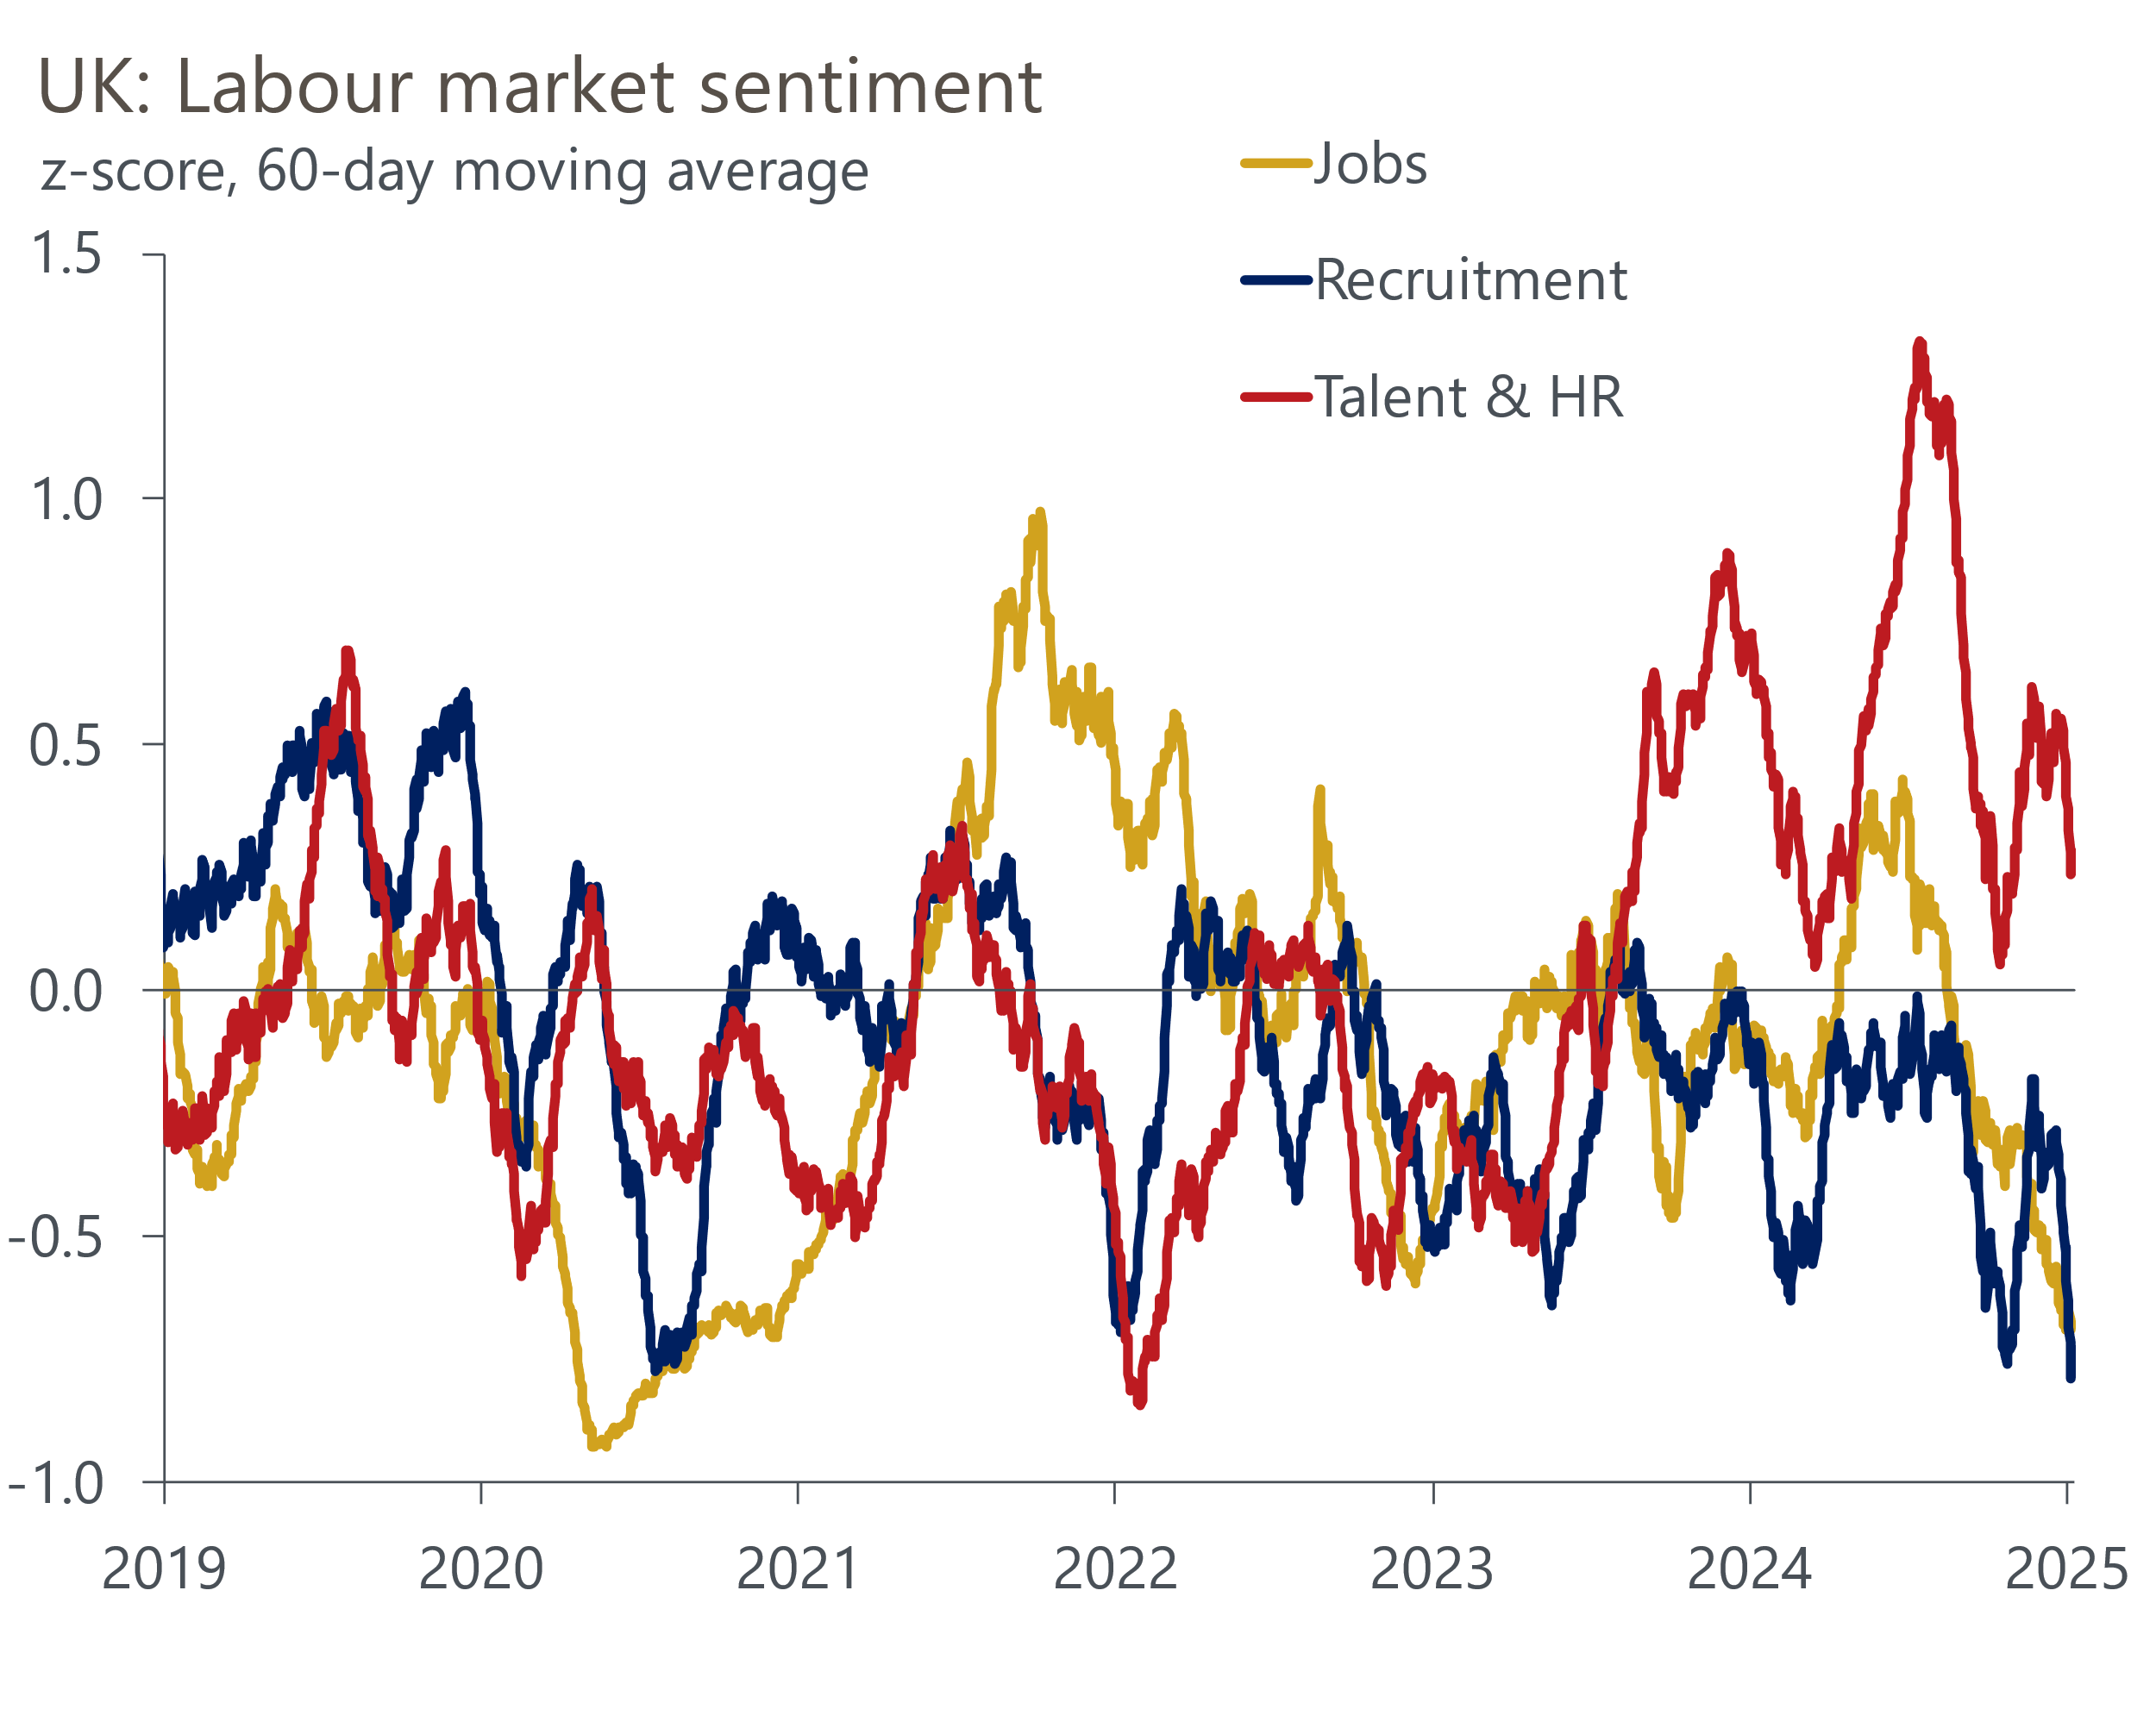
Source: Oxford Economics/Penta
Our sentiment data-based employment nowcast suggests that year-on-year employment growth dropped to zero around the turn of the year, the weakest reading since mid-2021 (Chart 1). This is broadly consistent with recent business survey data, but is in marked contrast to the jump in employment growth reported by the LFS in H2 2024.
Our regular pay indicator shows greater resilience (Chart 7). Year-on-year growth in the ONS average weekly earnings series accelerated back to 6% in late-2024. But base effects caused by a soft reading for October 2023 and compositional effects played a major role in the pickup. Our indicator has been softer, stabilising at around 4.5% at the turn of the year. This is still some way above the pace that the BoE considers to be consistent with achieving the inflation target over the medium-term. It's also slightly higher than the top of the range of potential outcomes identified recently by the BoE's regional agents.
Chart 7: Our nowcast suggests pay growth has stabilised at around 4.5%
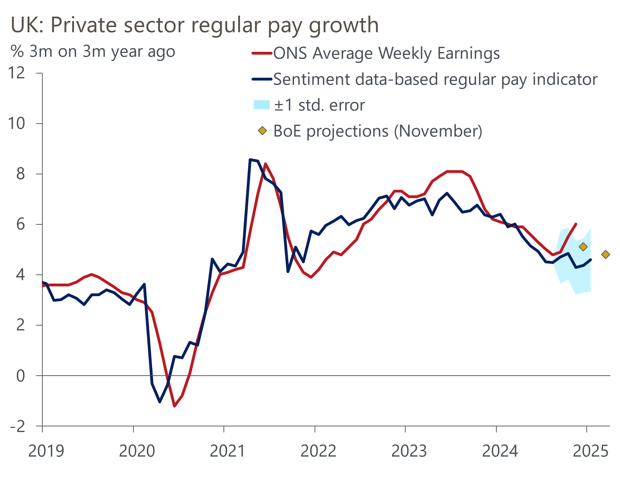
Source: Oxford Economics/Penta/Haver Analytics
In the minutes of the MPC's December meeting, the Committee highlighted the potential trade-off between more persistent inflationary pressures and greater weakness in output and employment. The combination of a weakening jobs outlook and resilience in pay growth flagged by our nowcasts suggests this trade off will come into sharper focus as we move through 2025.
April's increases in employers' national insurance contributions and the national living wage will be key influences on how this trade-off plays out. Movements in our sentiment scores over the past couple of months are likely to partly reflect the announcements on both policies in the Budget at the end of October. But many companies will still be adapting their plans. We will look at the impact these policies could have on the labour market in a forthcoming note.

